Trauma Informed Care Policy Review Tool | 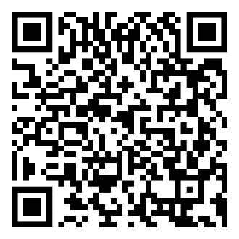
http://tinyurl.com/Review-Tool
Learning Brain Vs. Survival Brain | 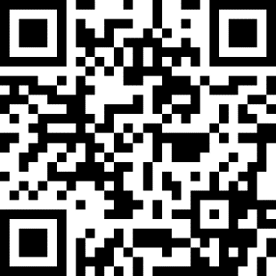
http://tinyurl.com/LearningVsSurvival
Dr. Siegel's Hand Model | 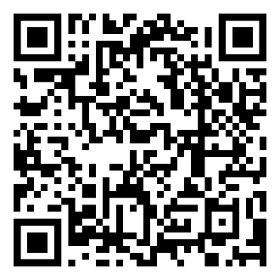
http://tinyurl.com/Hand-Model
5 Ways to Build Resilience in Students | 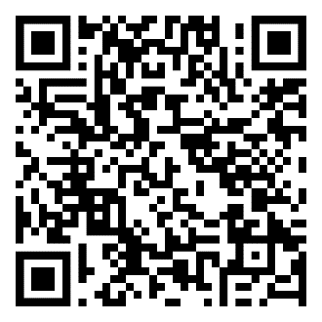
http://tinyurl.com/ResilienceInStudents

